**Karmani Production Deployment Steps**

**Step-1 -> Build or Publish the Required Projects**

**1. Publish the backed API project to some local folder and zip the folder.**

**a. Click on the "Build" menu**: Click on the **"Build"** menu in the menu bar at the top of the Visual Studio window.

**b. Select "Publish”:** In the "Build" menu, select **"Publish EDCS_KARMANI_API"**. This will open the Publish dialog.

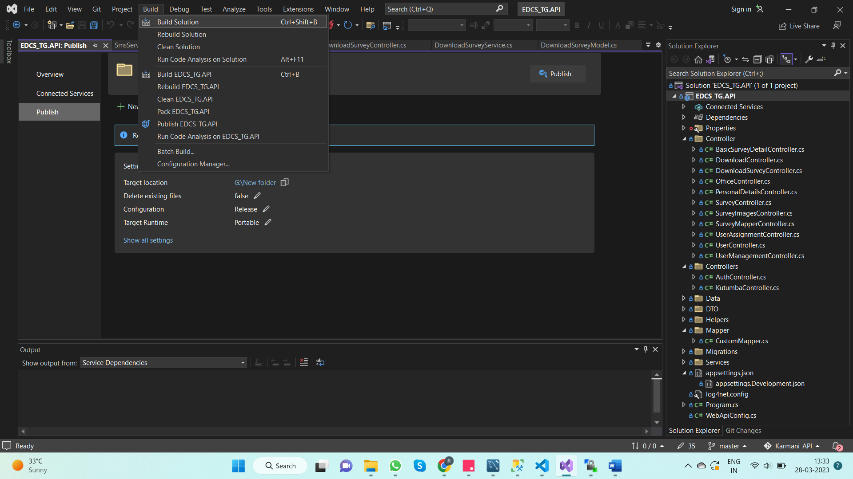

**c. Select a publish target**: In the Publish dialog, select a publish target. In this case a local folder is chosen to publish the project.

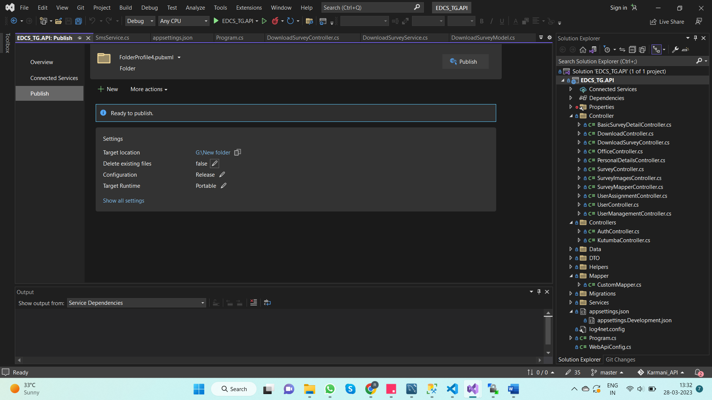

**d. Configure publishing settings**: Depending on the publish target we choose, we need to configure various publishing settings, such as connection settings, database settings, and other deployment options.

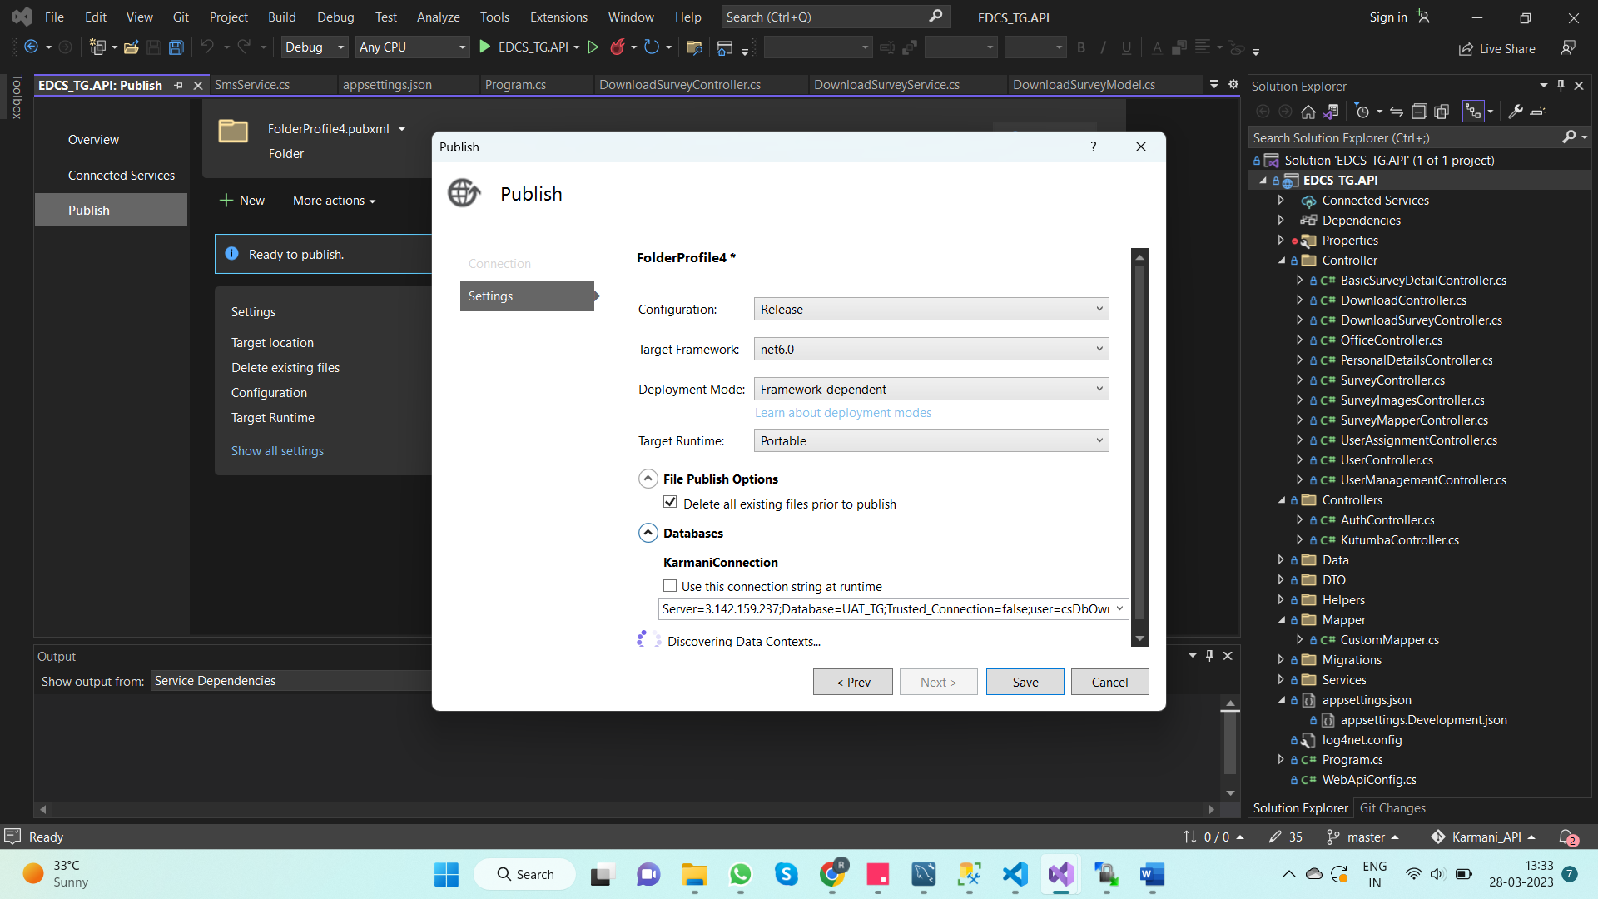

**e. Preview and publish the project**: After configuring the publishing settings, preview the changes and verify that everything properly configured. Click the **"Publish"** button to publish the project to the selected folder.

**f.** Zip the published folder and rename it as **“API_20230328.zip”** (API_ followed by current date)

**2. Build the front end react project and zip the build folder**

**a.** Open the react project in vs code.

**b.** Open new terminal.

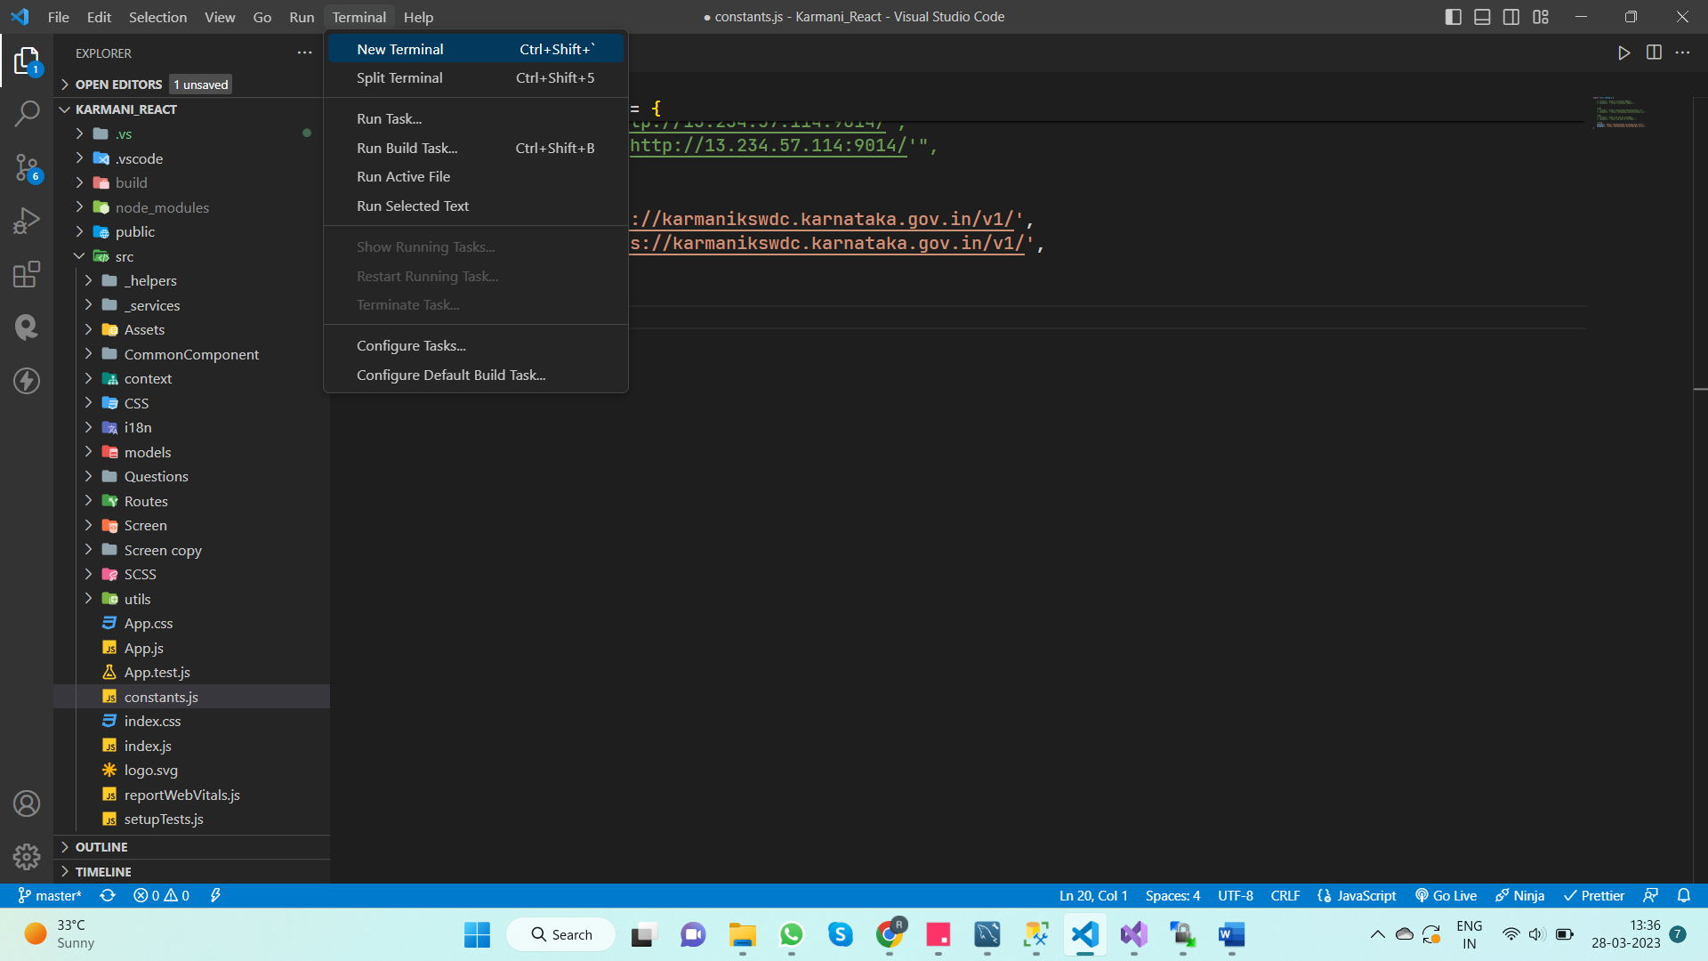

**c.** Run the command **“npm run build”** to build the project.

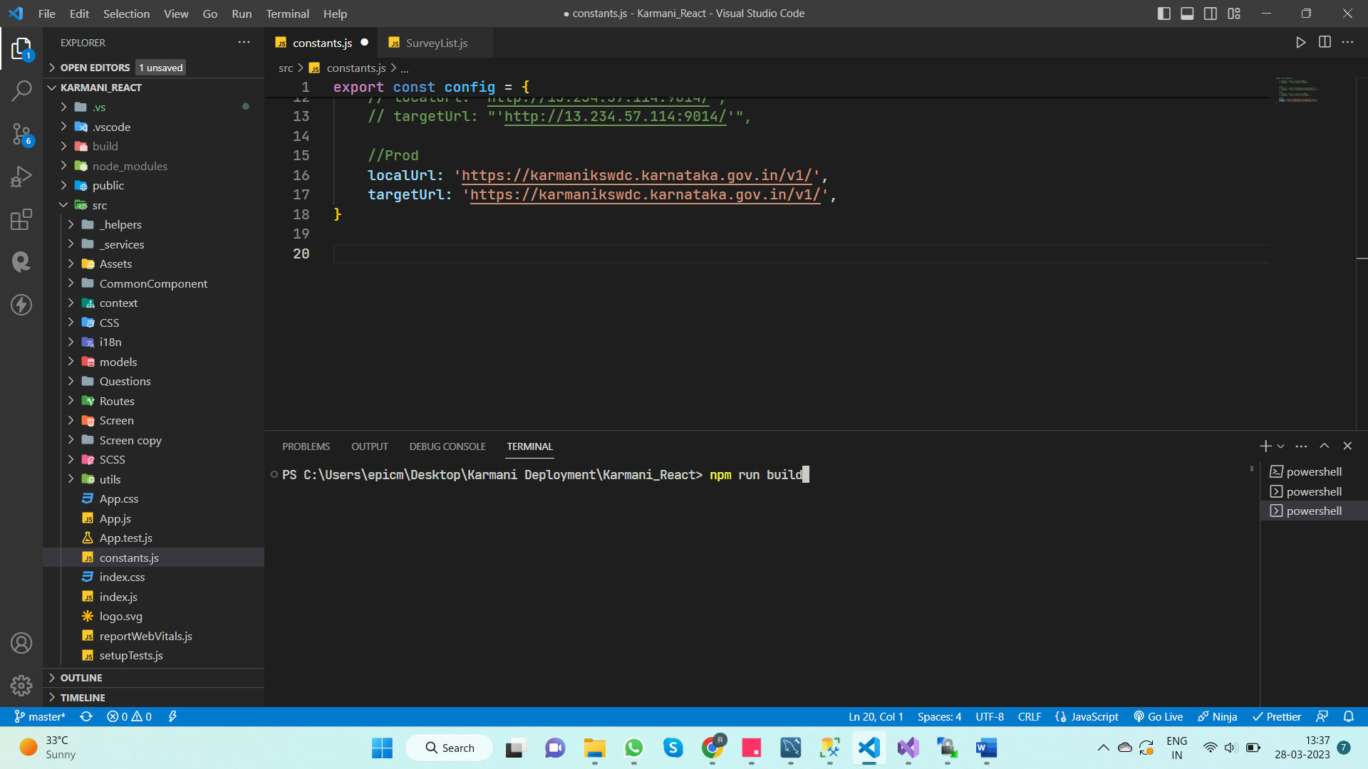

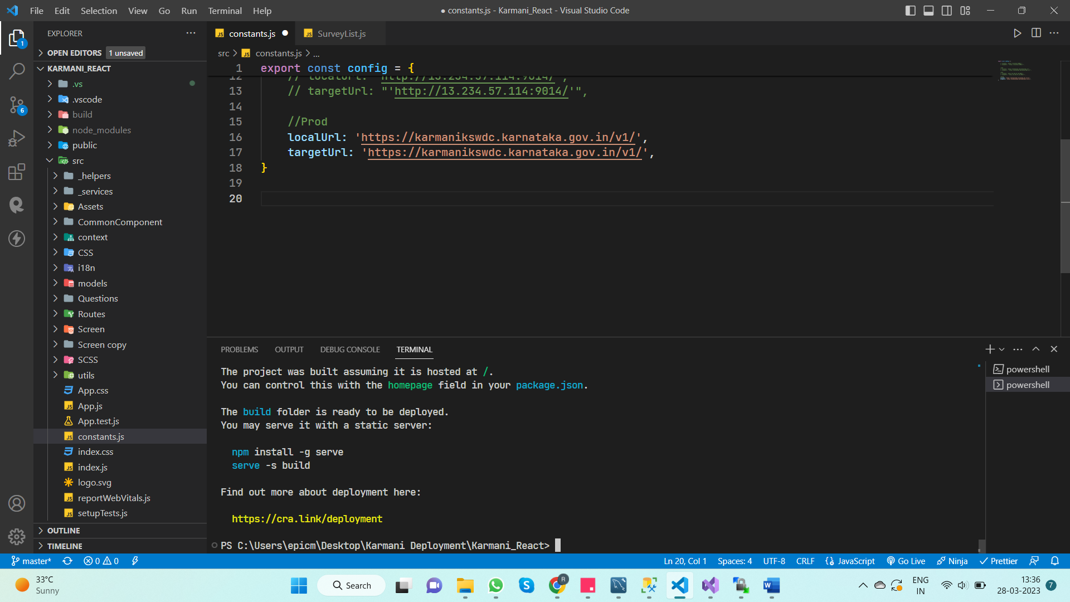

**d.** Zip the build folder and rename it as **“React_20230328.zip”** (React_ followed by current date).

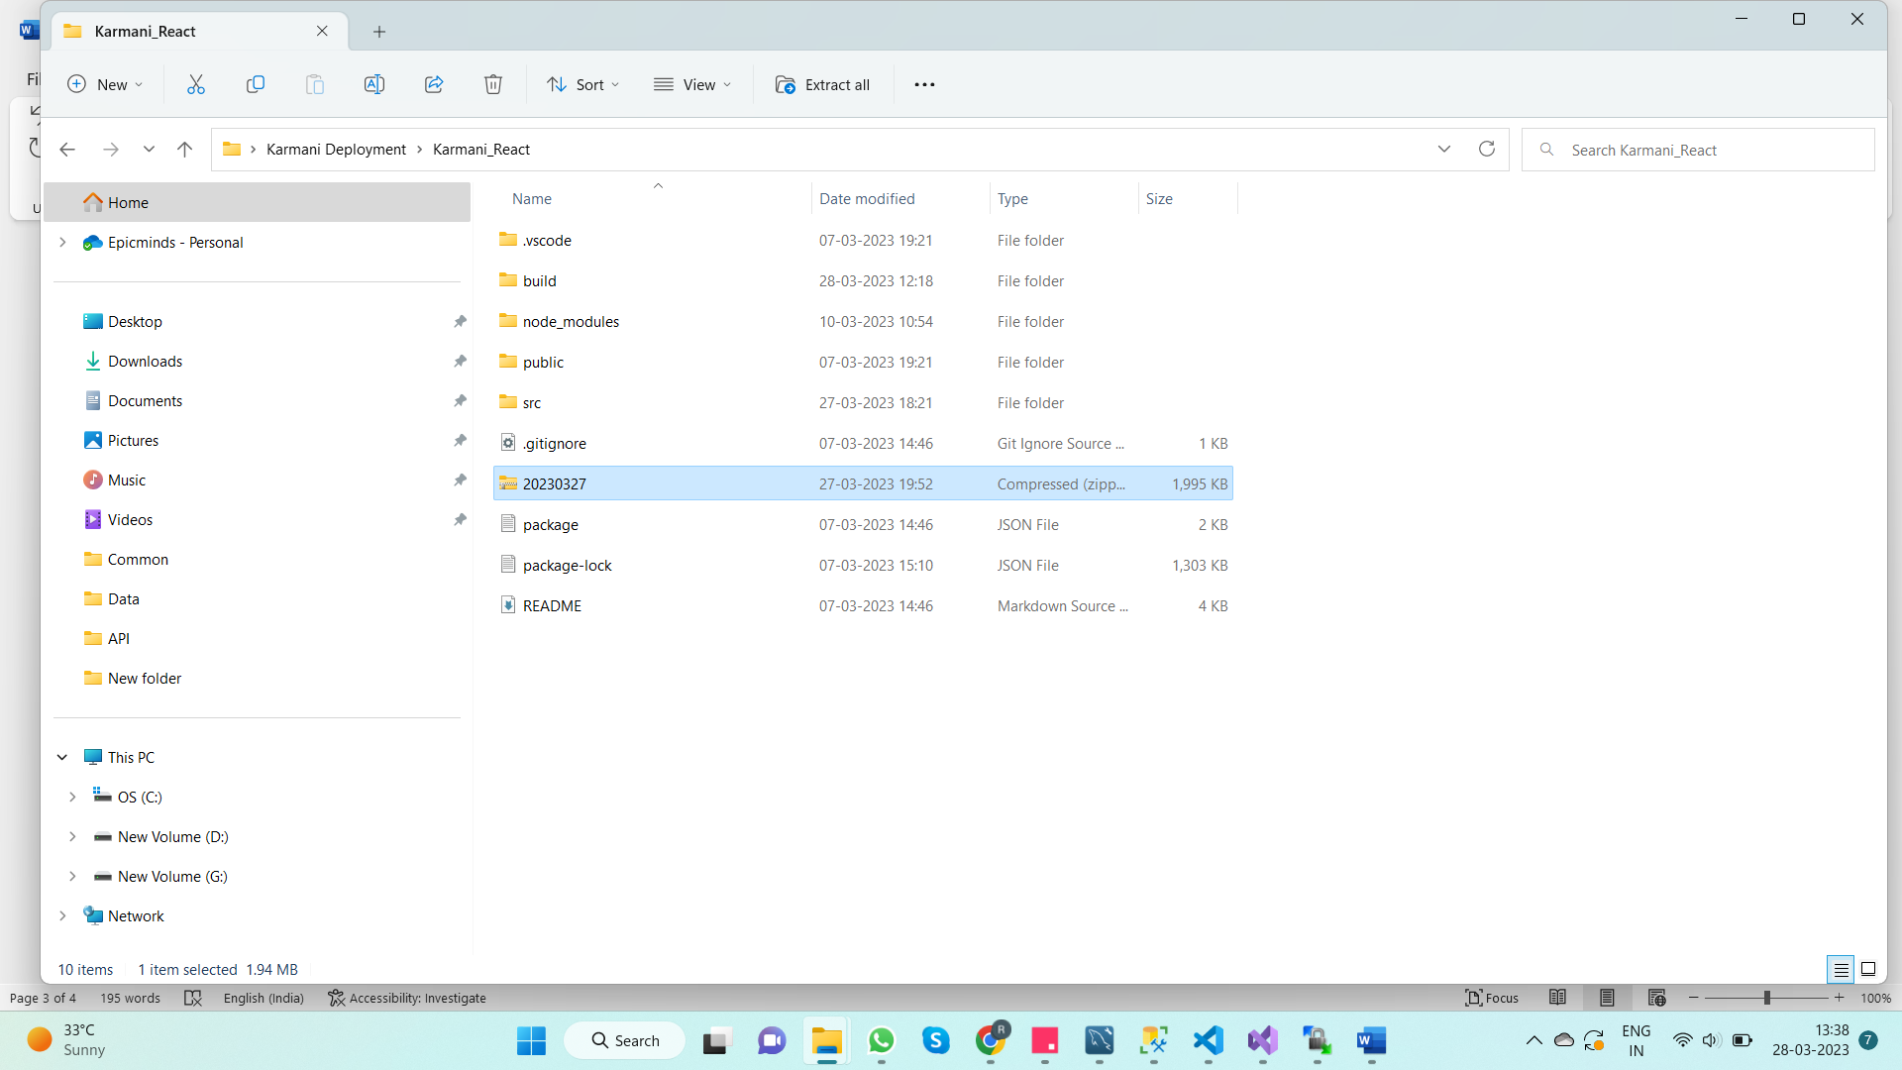

**Step-2 -> Copy the zipped folder to remote directory**

1. Open “**WinSCP”** and connect to the server **“103.138.197.48” (All the server related credentials are available in server laptop desktop as “karmani_Login.txt”)**

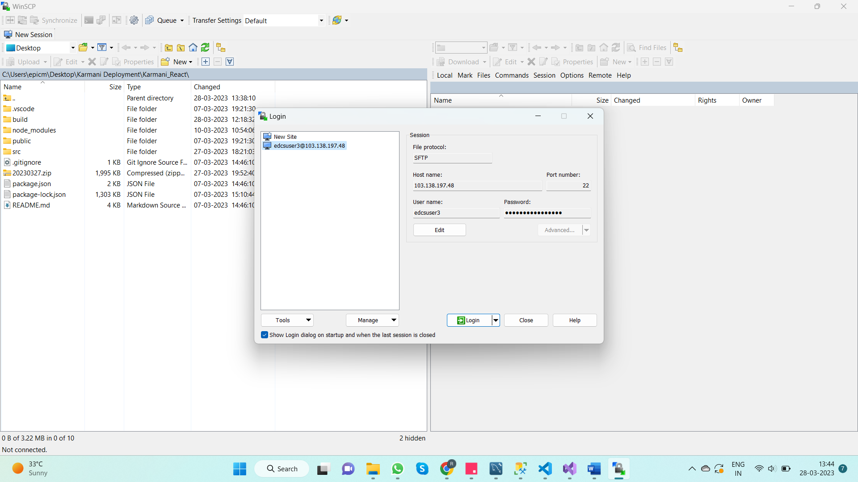

1. Once connected to remote server through **WinSCP**, you will see the remote directory tree on the right-hand side of the window, and your local directory tree on the left-hand side.

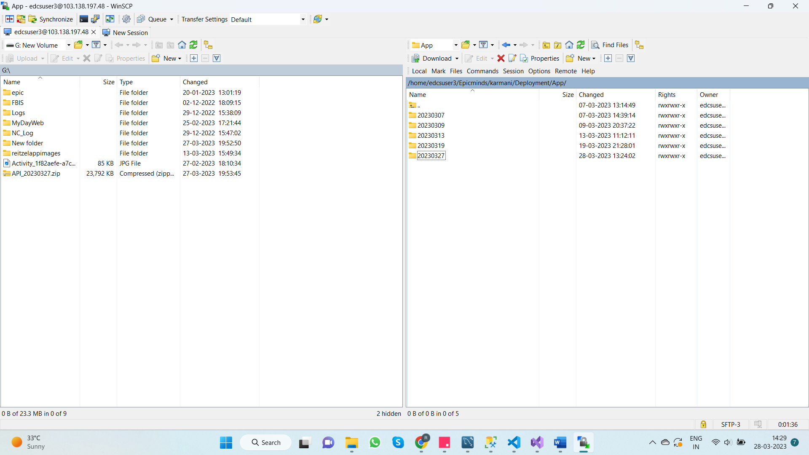

1. Now, drag and drop the zipped project folders to the path **“/home/edcsuser3/Epicminds/karmani/Deployment/App/20230327”**

**(Folder name should be current date)**

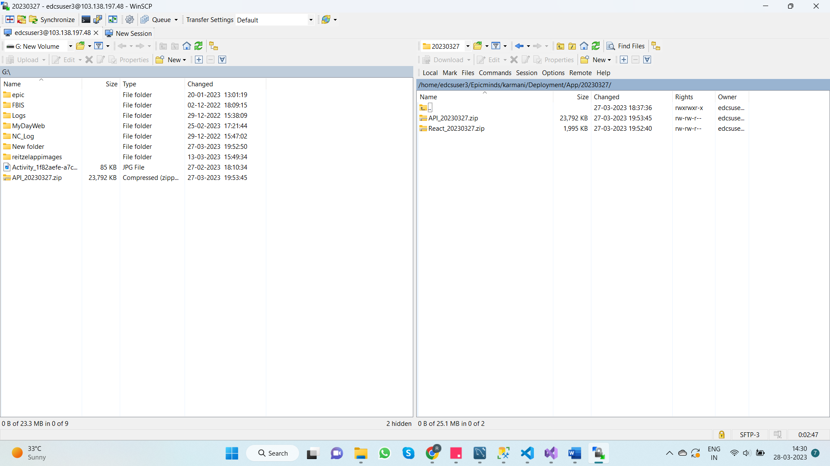

**Steps to be followed in Server laptop**

**Step-1 -> Copy the Zipped folder from WinScp server to application server**

1. Open RDC (windows+R and type mstsc and enter) in Server Laptop and connect to application server (**10.10.135.171**)

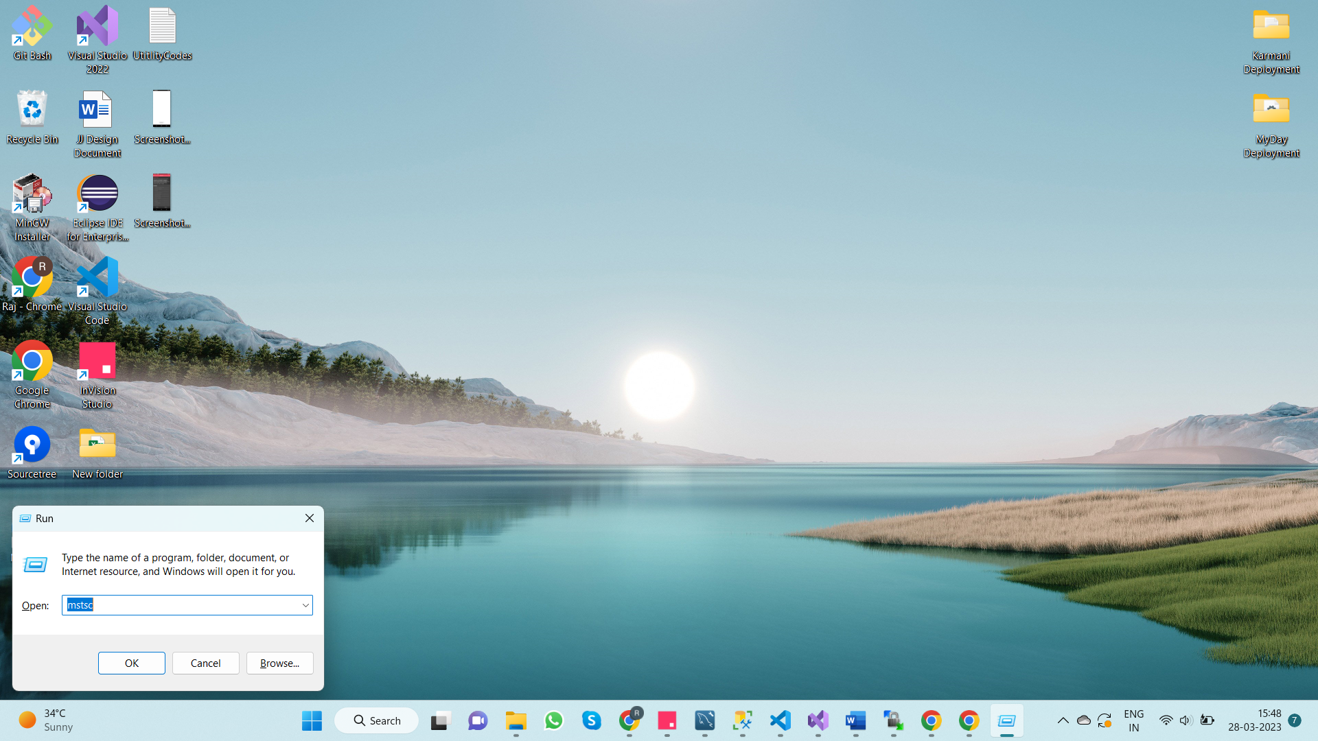

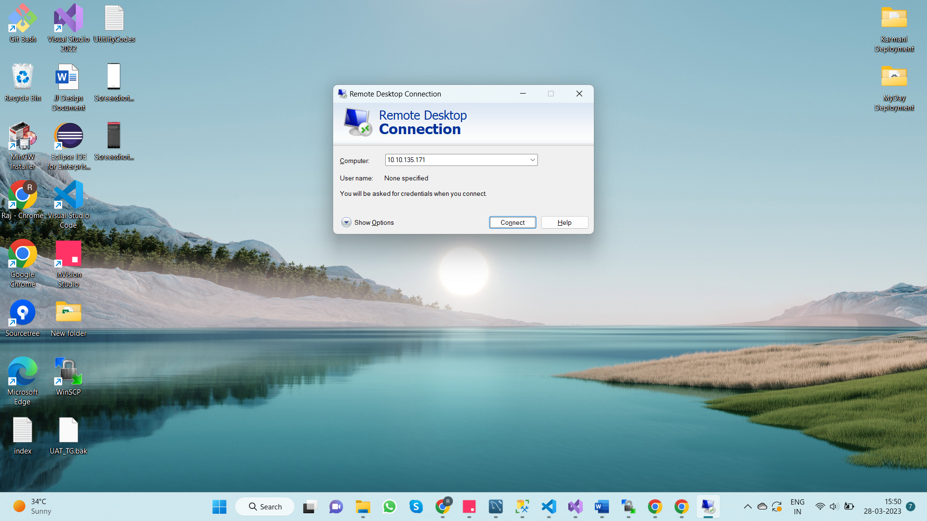

1. Open WinScp in Application server and connect to **“10.10.135.56”**

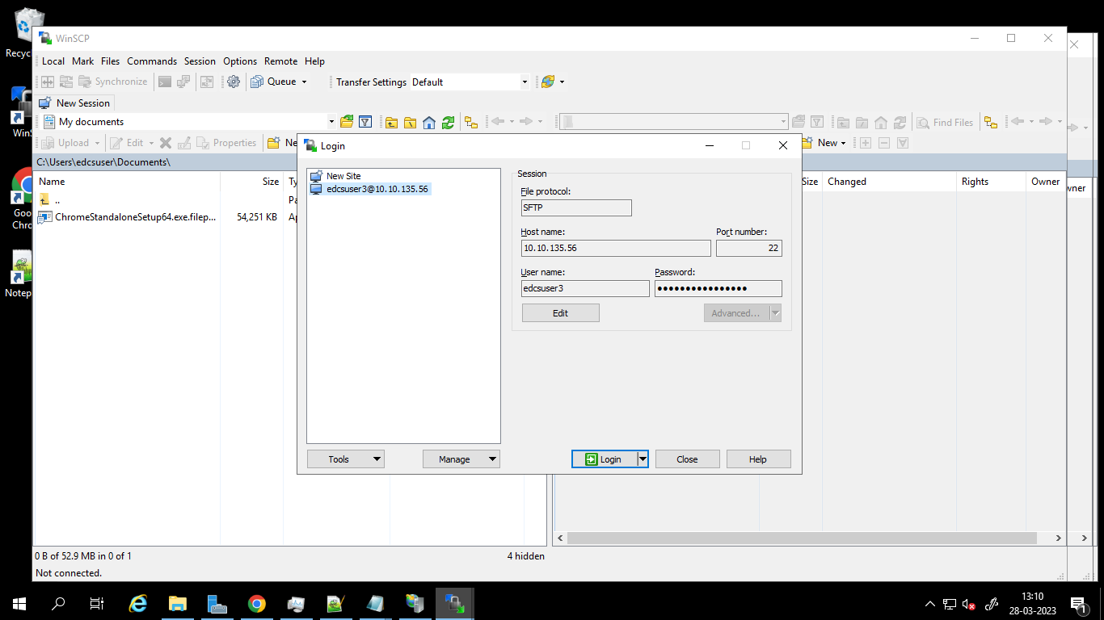

1. Copy the zipped folder from the path **“/home/edcsuser3/Epicminds/karmani/Deployment/App/20230327”**

To

**“E:\Epicminds\Code\20230327” (Folder name is current date)**

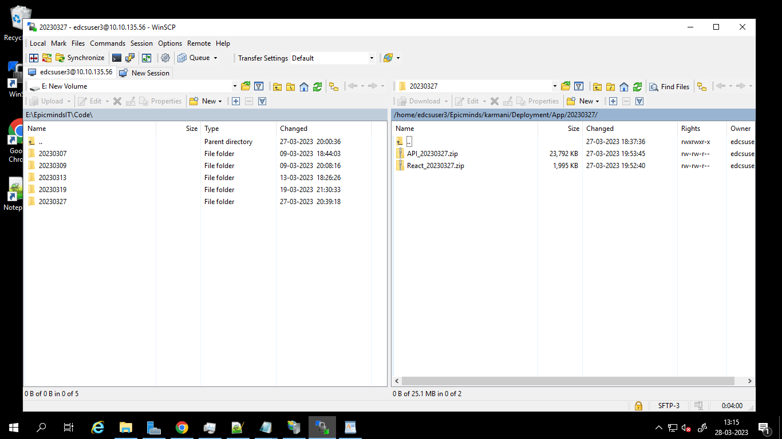

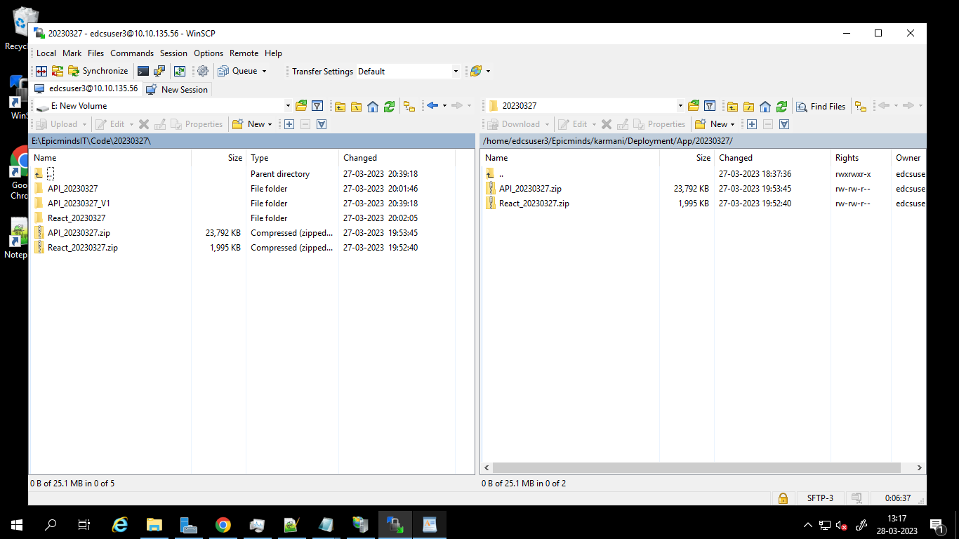

1. Unzip the folders

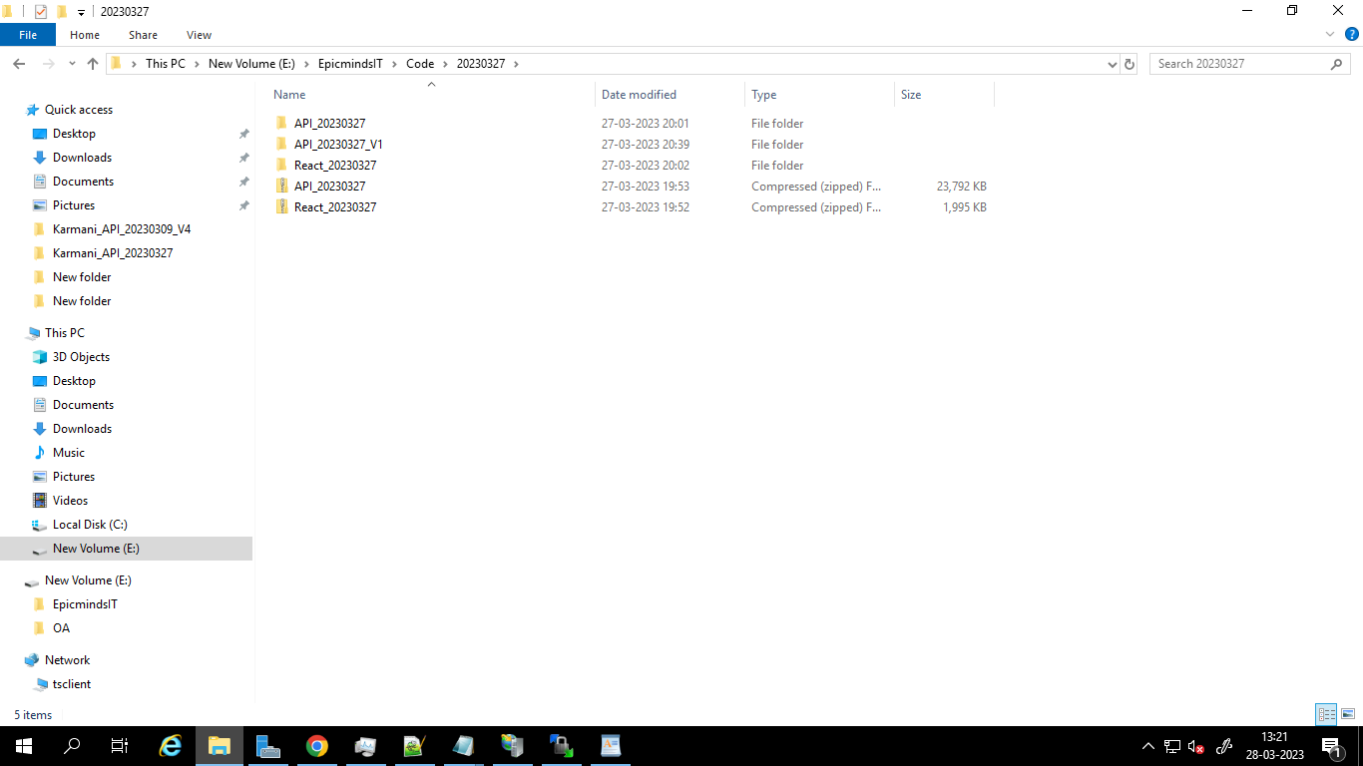

**Steps to Deploy the Project**

**Step – 1 – Stop the currently running servers**

1. Open IISC manager in application server

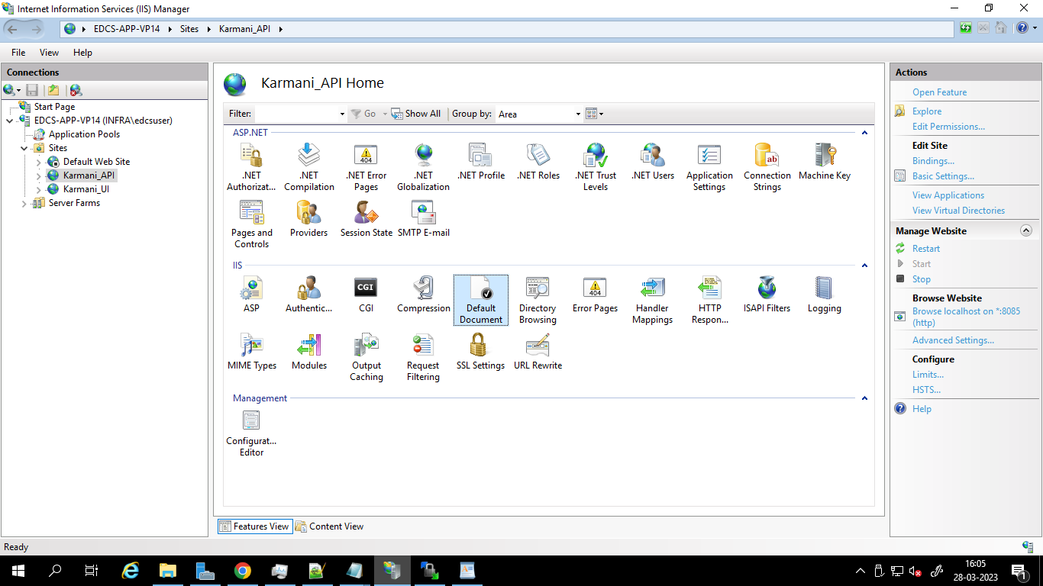

1. Under connections section locate and Double click on **Karmani_API** on left hand side and on the right hand side locate Manage website to fine 3 options **Restart,Start and stop** and click on **stop** to stop the server.

Image



1. Do the same thing for **Karmani_UI**.

Image

**Step – 2 – Change The physical Path of project Location**

1. API
2. Go to the path **“C:/inetpub/wwwroot/Karmani/API”** and create a folder named **“Karmani_API_20230321” (suffix it with current date)**

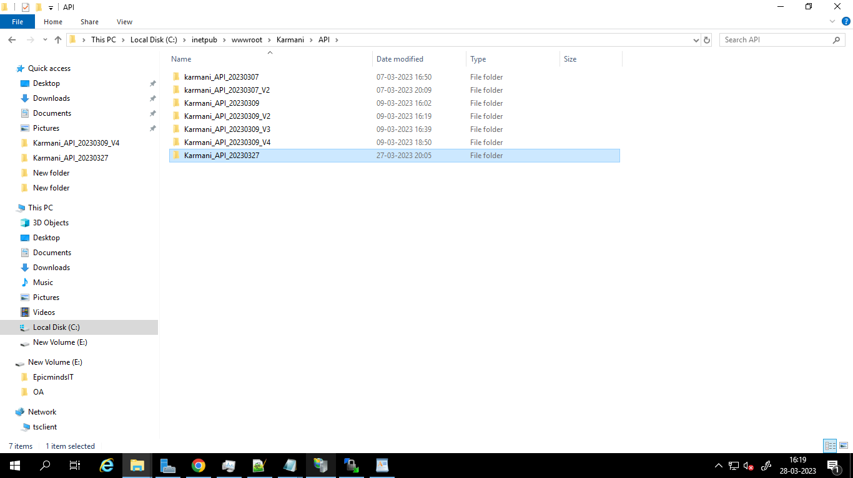

1. Copy the contents from the path **“E:\Epicminds\Code\20230327\API_20230327”** and paste tothepath **“C:/inetpub/wwwroot/Karmani/API/ Karmani_API_20230321”**

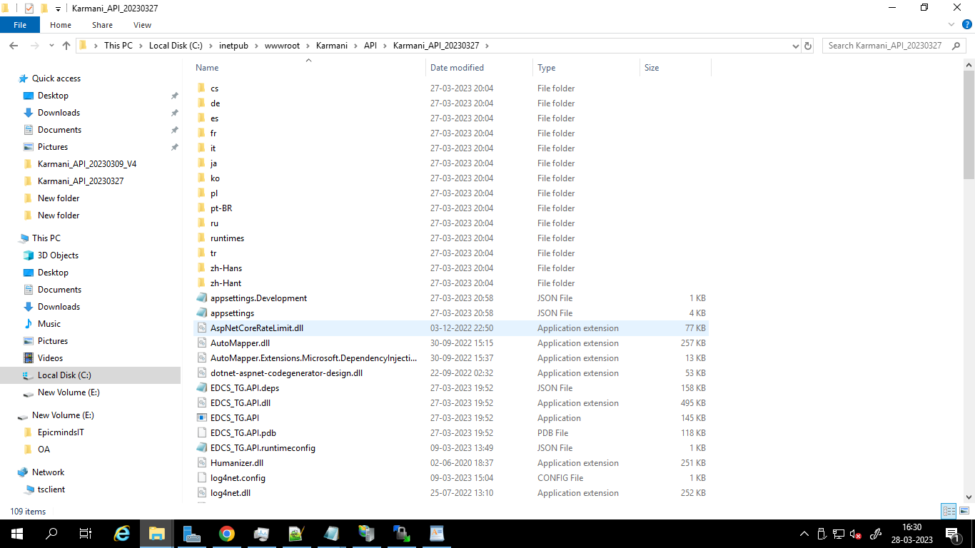

1. Open recently deployed project and copy the following files **(“appsetting” , “appsettings.development”, “log4net.config”)** and replace it in the latest project folder.

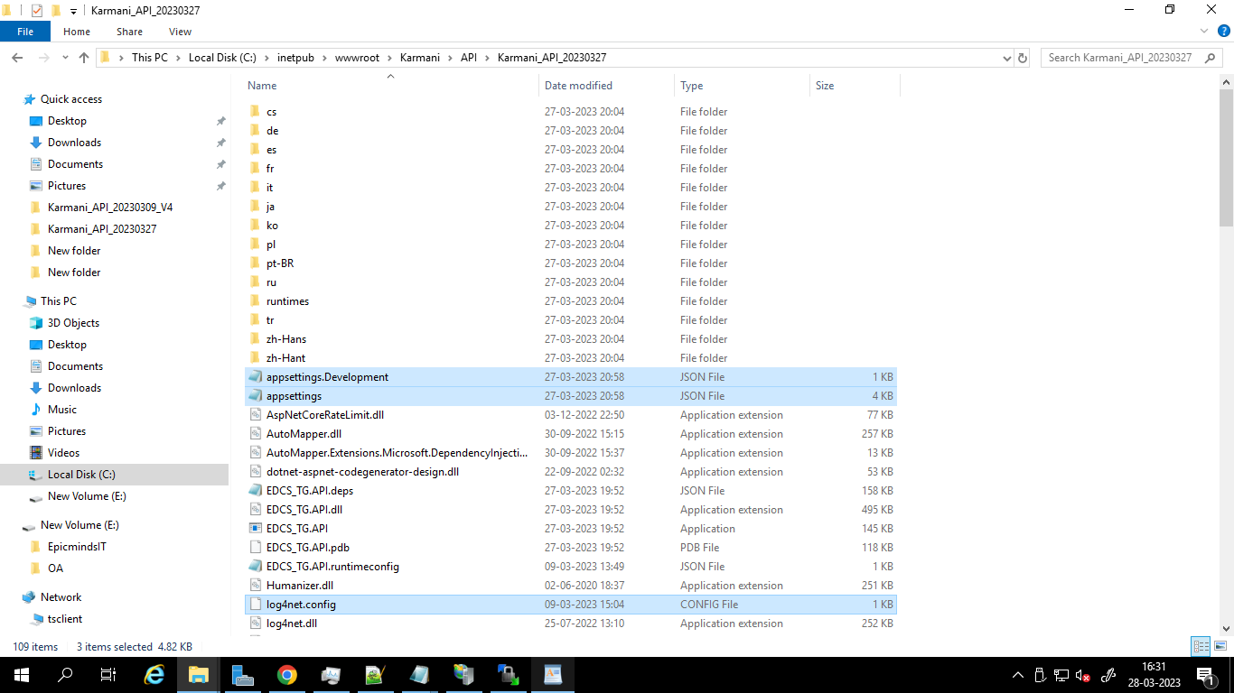

1. Change the physical path of the project to current folder in IISC manager

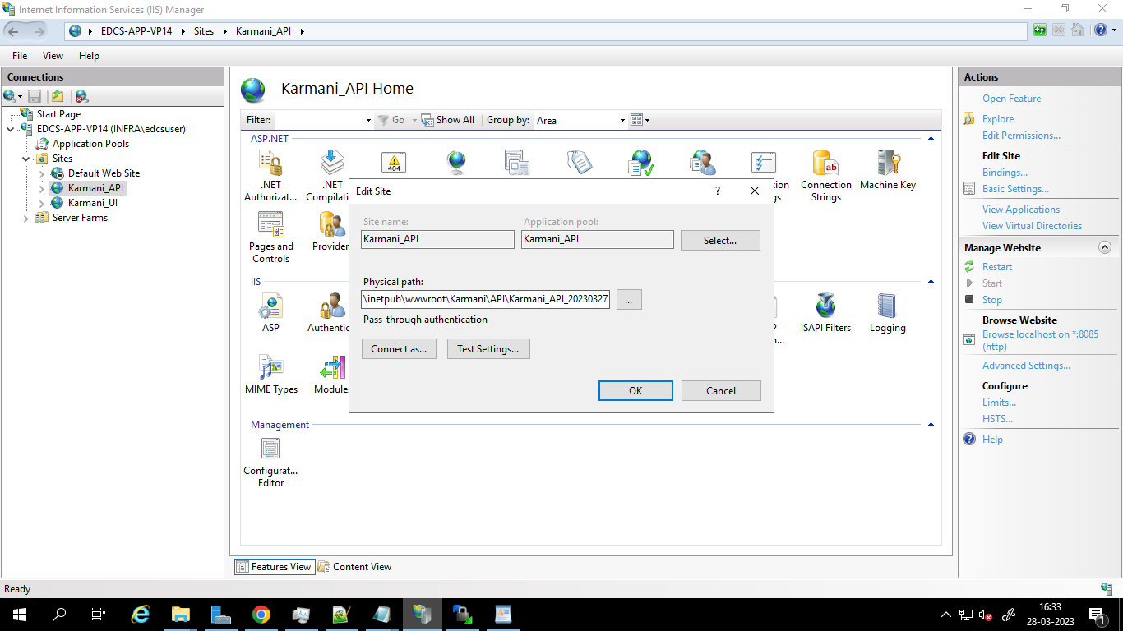

1. UI
2. Go to the path **“C:/inetpub/wwwroot/Karmani/React”** and create a folder named **“React_20230321” (suffix it with current date)**

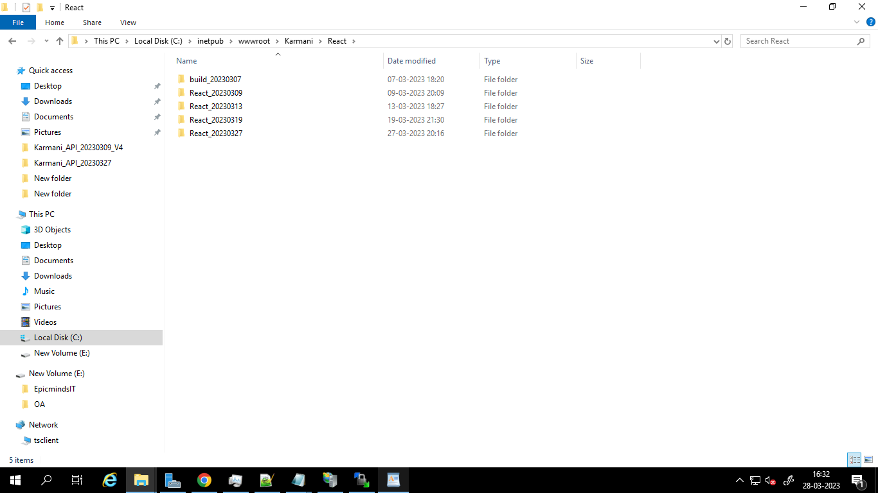

1. Copy the contents from the path **“E:\Epicminds\Code\20230327\React_20230327”** and paste tothepath **“C:/inetpub/wwwroot/Karmani/React/ React_20230321”**

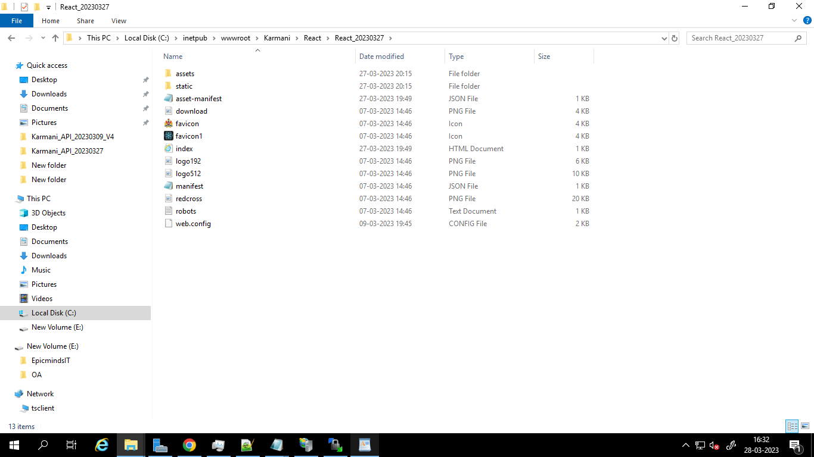

1. Open recently deployed project and copy the following file **(“web.config”)** and replace it in the latest project folder.

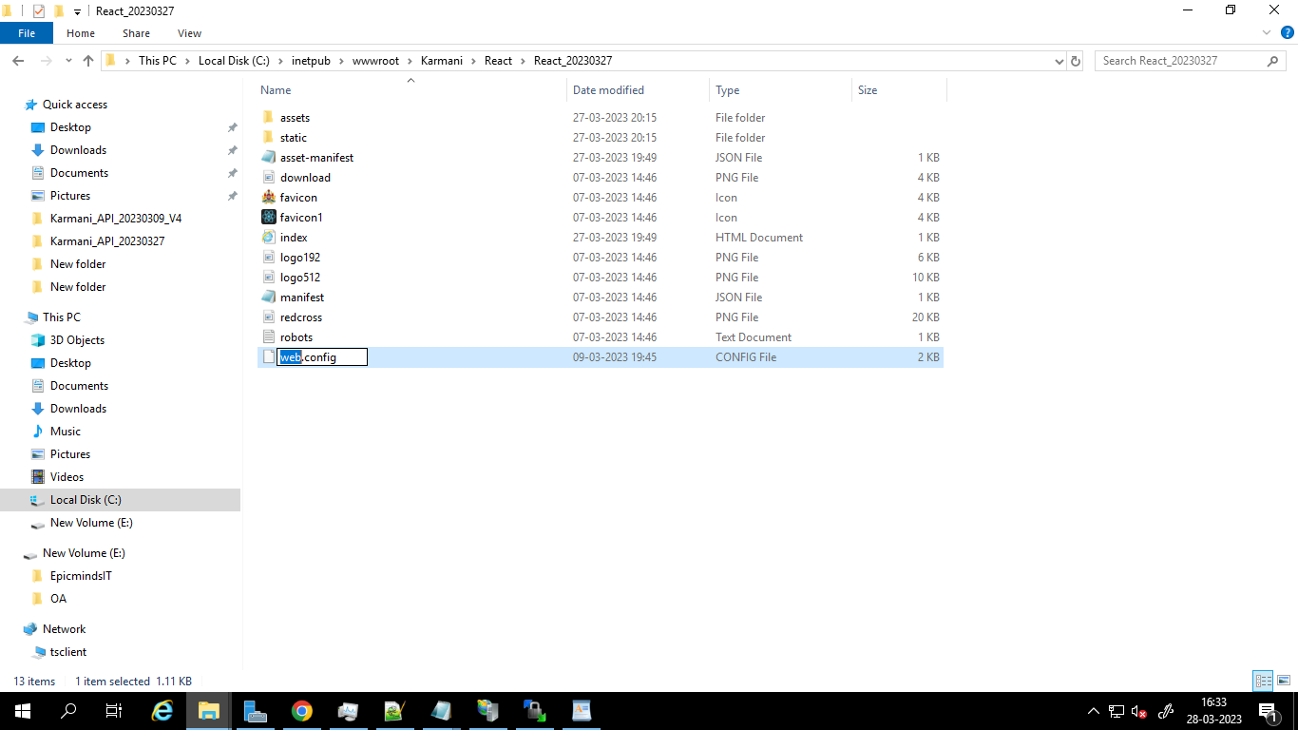

1. Change the physical path of the project to current folder in IISC manager

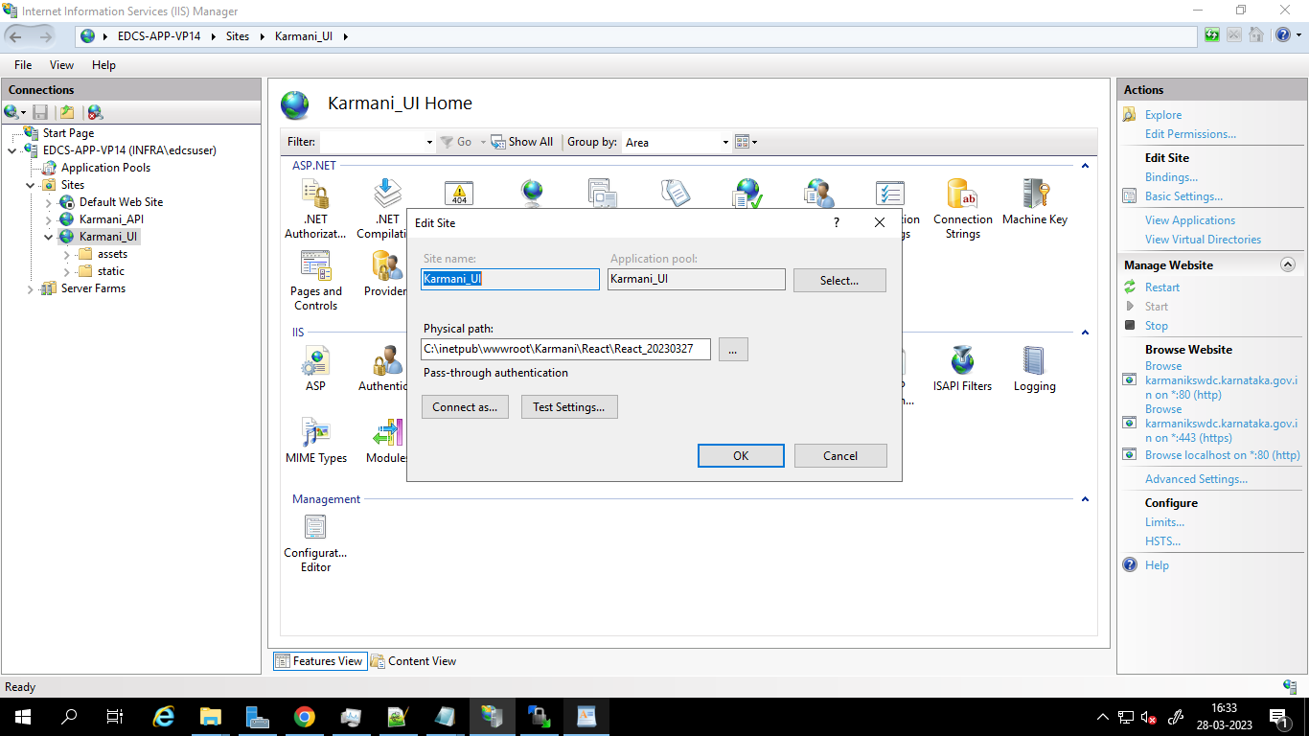

**Step – 3 – Start the servers**

1. Start the API server by click on start under manage Website

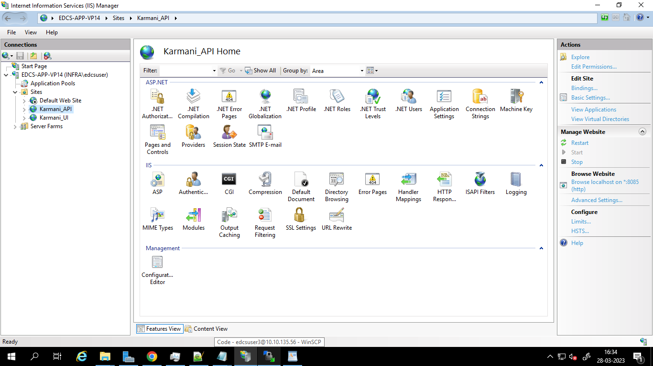

1. Start the UI server by click on start under manage Website

